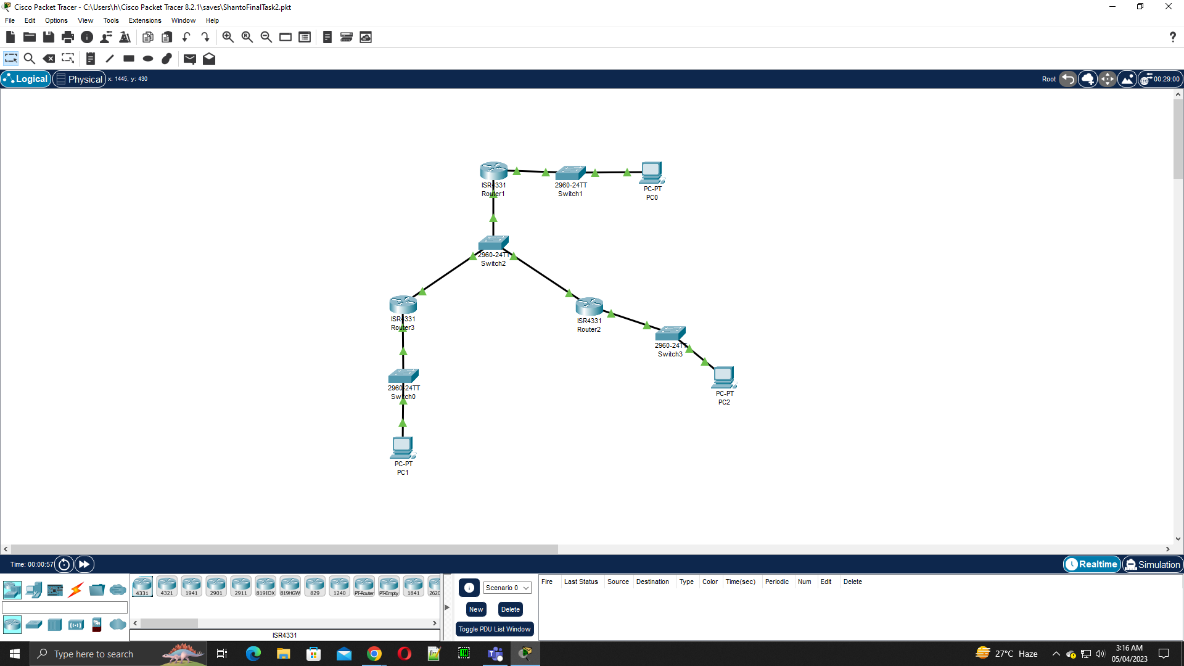

Wed Apr 5 02:57:37 2023 Router2 Router>en

Wed Apr 5 02:57:59 2023 Router2 Router#configure terminal

Wed Apr 5 02:58:19 2023 Router2 Router(config)#interface GigabitEthernet0/0/0

Wed Apr 5 02:58:30 2023 Router2 Router(config-if)#ip address 10.10.10.2 255.0.0.0

Wed Apr 5 02:58:49 2023 Router2 Router(config-if)#ip address 10.10.10.2 255.255.255.0

Wed Apr 5 02:58:53 2023 Router2 Router(config-if)#no shutdown

Wed Apr 5 02:58:56 2023 Router2 Router(config-if)#exit

Wed Apr 5 02:59:03 2023 Router2 Router(config)#interface GigabitEthernet0/0/1

Wed Apr 5 02:59:08 2023 Router2 Router(config-if)#ip address 172.16.1.250 255.255.0.0

Wed Apr 5 02:59:15 2023 Router2 Router(config-if)#ip address 172.16.1.250 255.255.255.0

Wed Apr 5 02:59:20 2023 Router2 Router(config-if)#no shutdown

Wed Apr 5 02:59:23 2023 Router2 Router(config-if)#exit

Wed Apr 5 03:01:07 2023 Router2 Router(config)#router ospf 1

Wed Apr 5 03:01:13 2023 Router2 Router(config-router)#network 172.16.1.0 0.0.0.255 area 0

Wed Apr 5 03:01:18 2023 Router2 Router(config-router)#network 10.10.20.0 0.0.0.255 area 0

Wed Apr 5 03:01:24 2023 Router2 Router(config-router)#end

Wed Apr 5 03:01:31 2023 Router2 Router#configure terminal

Wed Apr 5 03:01:39 2023 Router2 Router(config)#interface GigabitEthernet0/0/1

Wed Apr 5 03:01:45 2023 Router2 Router(config-if)#ip address 172.16.1.253 255.255.255.0

Wed Apr 5 03:01:53 2023 Router2 Router(config-if)#exit

Wed Apr 5 03:02:00 2023 Router2 Router(config)#interface GigabitEthernet0/0/1

Wed Apr 5 03:02:05 2023 Router2 Router(config-if)#if)#exit

Wed Apr 5 03:02:08 2023 Router2 Router(config-if)#exit

Wed Apr 5 03:02:28 2023 Router2 Router(config)#exit

Wed Apr 5 03:02:38 2023 Router2 Router#ping 10.10.20.254

Wed Apr 5 03:04:12 2023 Router1 Router>en

Wed Apr 5 03:04:25 2023 Router1 Router#configure terminal

Wed Apr 5 03:04:31 2023 Router1 Router(config)#interface GigabitEthernet0/0/0

Wed Apr 5 03:04:37 2023 Router1 Router(config-if)#ip address 10.10.10.254 255.0.0.0

Wed Apr 5 03:04:44 2023 Router1 Router(config-if)#ip address 10.10.10.254 255.255.255.0

Wed Apr 5 03:04:51 2023 Router1 Router(config-if)#no shutdown

Wed Apr 5 03:04:54 2023 Router1 Router(config-if)#exit

Wed Apr 5 03:05:04 2023 Router1 Router(config)#interface GigabitEthernet0/0/1

Wed Apr 5 03:05:11 2023 Router1 Router(config-if)#ip address 10.10.20.1 255.255.255.0

Wed Apr 5 03:05:23 2023 Router1 Router(config-if)#ip address 10.10.20.1 255.255.255.0

Wed Apr 5 03:05:31 2023 Router1 Router(config-if)#no shutdown

Wed Apr 5 03:05:34 2023 Router1 Router(config-if)#exit

Wed Apr 5 03:05:52 2023 Router1 Router(config)#router ospf 1

Wed Apr 5 03:05:59 2023 Router1 Router(config-router)#network 10.10.10.0 0.0.0.255 area 0

Wed Apr 5 03:06:10 2023 Router1 Router(config-router)#network 10.10.20.0 0.0.0.255 area 0

Wed Apr 5 03:06:15 2023 Router1 Router(config-router)#exit

Wed Apr 5 03:06:35 2023 Router1 Router(config)#exit

Wed Apr 5 03:07:41 2023 Router3 Router>en

Wed Apr 5 03:07:48 2023 Router3 Router#configure terminal

Wed Apr 5 03:08:02 2023 Router3 Router(config)#interface GigabitEthernet0/0/0

Wed Apr 5 03:08:07 2023 Router3 Router(config-if)#ip address 10.10.10.251 255.0.0.0

Wed Apr 5 03:08:10 2023 Router3 Router(config-if)#exit

Wed Apr 5 03:08:16 2023 Router3 Router(config)#interface GigabitEthernet0/0/1

Wed Apr 5 03:08:25 2023 Router3 Router(config-if)#exit

Wed Apr 5 03:08:32 2023 Router3 Router(config)#interface GigabitEthernet0/0/0

Wed Apr 5 03:08:43 2023 Router3 Router(config-if)#ip address 10.10.10.251 255.255.255.0

Wed Apr 5 03:08:46 2023 Router3 Router(config-if)#exit

Wed Apr 5 03:08:56 2023 Router3 Router(config)#interface GigabitEthernet0/0/1

Wed Apr 5 03:09:05 2023 Router3 Router(config-if)#ip address 192.168.1.252 255.255.255.0

Wed Apr 5 03:09:12 2023 Router3 Router(config-if)#no shutdown

Wed Apr 5 03:09:16 2023 Router3 Router(config-if)#exit

Wed Apr 5 03:09:33 2023 Router3 Router(config)#interface GigabitEthernet0/0/0

Wed Apr 5 03:09:36 2023 Router3 Router(config-if)#no shutdown

Wed Apr 5 03:09:39 2023 Router3 Router(config-if)#exit

Wed Apr 5 03:11:05 2023 Router3 Router(config)#router ospf 1

Wed Apr 5 03:11:11 2023 Router3 Router(config-router)#network 172.168.1.0 0.0.0.255 area 0

Wed Apr 5 03:11:18 2023 Router3 Router(config-router)#network 10.10.10.0 0.0.0.255 area 0

Wed Apr 5 03:11:22 2023 Router3 Router(config-router)#exit

Wed Apr 5 03:11:41 2023 Router3 Router(config)#exit

Wed Apr 5 03:11:48 2023 Router3 Router#ping 10.10.20.254

Wed Apr 5 03:12:04 2023 Router3 Router#ping 172.16.1.250

Wed Apr 5 03:12:39 2023 Router3 Router#ping 172.16.1.250

Wed Apr 5 03:12:58 2023 Router3 Router#ping 10.10.20.254